Mercury – This planet was named after the Roman Messenger god because of how fast it moves around the sun. Because it is the closest to the sun it takes 88 Earth days to make one lap around the sun meaning one year is only 88 days. It is the Smallest Planet at about 1/3 the size of earth with a diameter of 3,030 miles. Despite how fast it moves around the sun the planets spin is very slow, so a day lasts about 58 earth days! The temperature ranges from 800 degrees F to -290! This planed has a thick rocky outer shell that resembles the earths moon covered in impact craters from being struck by meteors and comets.
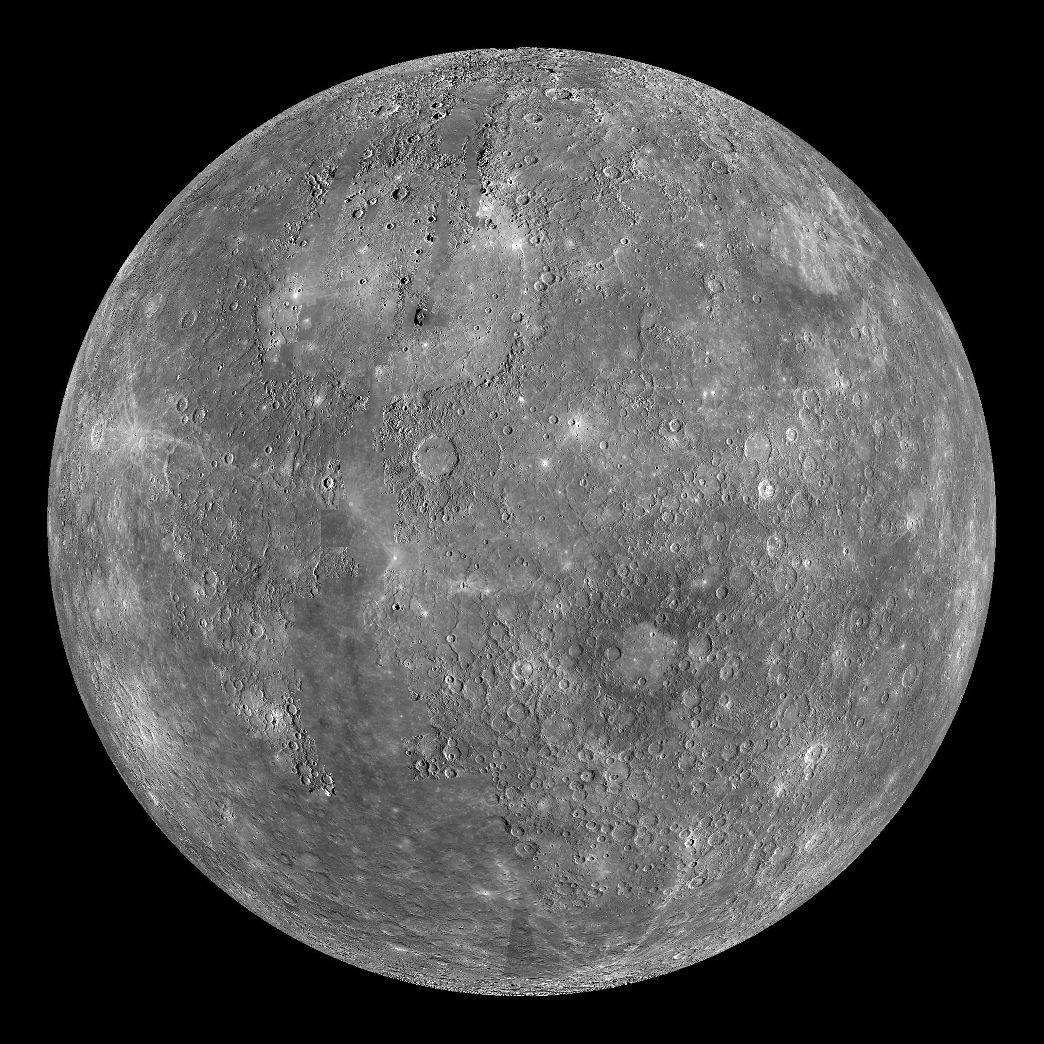
Venus – This is the 6th largest planet and second planet from the sun. It is the hottest planet and the brightest object in the earth’s sky after the sun and the moon. Because it is visible on earth it is often reported as a UFO, but in ancient records it was actually known as the Mourning Star and the Evening Star before it was discovered that it was actually a planet. Because of it’s bright yellow and red colors and reflective nature it was named after the goddess of love and beauty and is in fact the only planet named after a female deity. The average temperature is around 900 degrees F. It is just a little bit smaller than earth
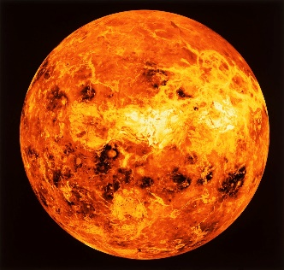
Earth – This planet is 5th largest planet and the only one not named after a Greek or Roman god. It is a Germanic word that means “The Ground.” If it were to have been named after a Greek God in the fashion of the others it would be known as Gaia, the mother of all life and ancestor to the gods themselves. It is nicknamed the “Third rock from the sun.” This planet has a diameter of 7,900 miles and can reach temperatures above 110 degrees F and below -126 degrees F. The core of this planet is estimated to be close to 10,000 degrees F.
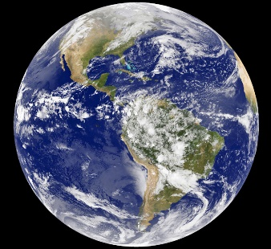
Mars – Because of its relative closeness to the earth this planet has been written about for over 4,000 years and therefore has no one person who claims credit for its discovery. It looks red because of the large quantity of iron oxide on its surface. This red appearance is the reason for it being named after the Roman god of War. Roughly half the size of Earth at 4,200 mi in diameter. A single day is 24.6 hours but a year is 669.6 earth days! On average the Temperature -80 degrees F.
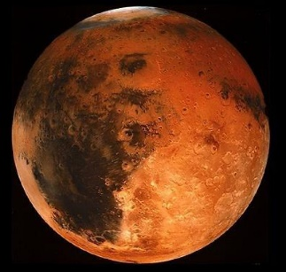
Jupiter – Although it is not right next to earth it is visible in earth’s night sky. Because of this, it has been known about since ancient times. There have been many cultures that named this planet but the common name used today is the name of the main Roman god. The Roman equivalent of the Greek god Zeus. Easily the largest planet in the solar system with a diameter of 88,846 miles, this planet is twice the size of all the other planets combined. The bulk of this planet is swirling gases and liquids, including a huge swirling storm that has been raging for hundreds of years and can be seen from space. This planet has 79 moons and 3 ring systems!
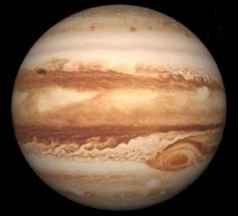
Saturn – Arguably the most recognizable planet due to its icy rings. This is the second largest planet after Jupiter with a diameter of 75,000miles (over 9 times the size of earth) and has the most known moons in the solar system at 82! Because of the slow orbit around the sun this planet is associated with time and as such was named for the Roman God of harvest and time. This planet is made almost entirely out of gases and if it could be placed on water it would float! A day on this planet is only about 10.6 hours but a year on this planet is the equivalent of almost 30 earth years! The average temperature on this planet is -175 degree F. The largest moon on this planet is in fact larger than the smallest planet in our solar system.
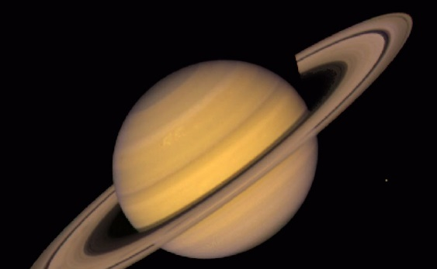
Uranus (Ouranos) – The third largest planet in the solar system at 31,763 miles in diameter, 4x the size of earth, this was the first planet that needed the help of a telescope to be discovered. This ice giant was named after the Greek god of the sky. Father sky was the counterpart to mother earth. This is the only planet that rotates on its side. Although not as well known for it, this planet also has visible rings! A year on this planet takes 84 earth years to complete, and a day lasts only 17 hours. This is the coldest planet at -371 degrees F.
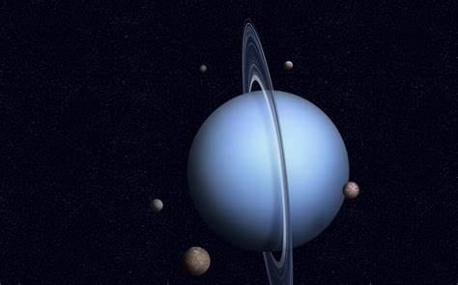
Neptune – This planet is the farthest from the sun and though it is the 4th largest planet in our solar system, it was the smallest of the planets labeled the gas giants. This planet was previously classified as a gas giant but is currently considered an ice giant. This is the only planet that cannot be seen with the naked eye. Its beautiful blue coloring earned it the name of the Roman god of the sea. A year on this planet takes 165 earth years to complete, this is the longest of all the planets. However, it has the shortest day of only 16 hours. This planet is about 4x the size of earth at 30,598 miles in diameter.
